**Complete and Submit the Website Project Check List with report**

|  |
| --- |
| **\*\*\* GitHub URL Progress upload of web site navigation and 3 pages – Week9** |
| **Project Report, Upload zipped folders all website files with report, (place college project on front page, no personal information to be included)** |
| **Minimum of 4 HTML Page Website** |
| **HTML5 standards and recommended page layout structure** (header,main,aside,article,section,footer) |
| **Include Meta data – description, keywords, author - Maximise SEO** |
| **Include font family for body of page** |
| **Appropriate use of External Style Sheet – Recommended CSS** |
| **Appropriate Example using Internal Styling on HTML page** (an example) |
| **Appropriate Example using use of inline Styling** (an example) |
| **Home page content aligned to each other and visually attractive** |
| **Consistency of design on all pages above fold, aligned, use of fonts, colour etc.** |
| **Appropriate use of Headings (h1, h2, h3, h4)** |
| **Appropriate use of Colours, easy to read and complimentary colours** |
| **Include an article or section with css that displays 2 or 3 columns** |
| **Clear, consistent and align content on page (reference all sources)** |
| **Include public domain images (with at least on image floated with text)** |
| **Use of background image** |
| **Include table of data/information** |
| **Include lists ordered and unordered (different shaped bullet points)** |
| **Include favicon and logo on your website** |
| **Include a contact form Display values entered in form and include red * beside required/mandatory input fields** |
| **Verify data collected on contact form, using get and data attached to URL** (Use the method get to display values entered on form will be appended to url and passed to server <form <action="http://foo.com" method="get">) |
| **Include google maps and suitable video** |
| **Footer information include** Copyright© year and footer menu |
| **Include Internal Links and External Links – Responsive webpages(70%)** |
| **Include Appropriate use of CSS Class and Id selectors** |
| **Additional Features ________Q and A page_____** |
| **W3C HTML & CSS Validator results (in report)** <https://validator.w3.org/nu/#file> |
| **Results of HTML5 Outliner (in report)** <https://validator.w3.org/nu/#file> |
| **Report include Proposal, Declaration of your own work , URL to Github, Rough Sketch of layout design, brief descriptions of the web site its pages and sources for information and Validator results** |
| **Website appearance, design and Content** [**https://webdesignledger.com/10-signs-of-a-user-focused-design/**](https://webdesignledger.com/10-signs-of-a-user-focused-design/)[**https://webdesignledger.com/20-dos-and-donts-of-effective-web-design/**](https://webdesignledger.com/20-dos-and-donts-of-effective-web-design/) |

Index.thml

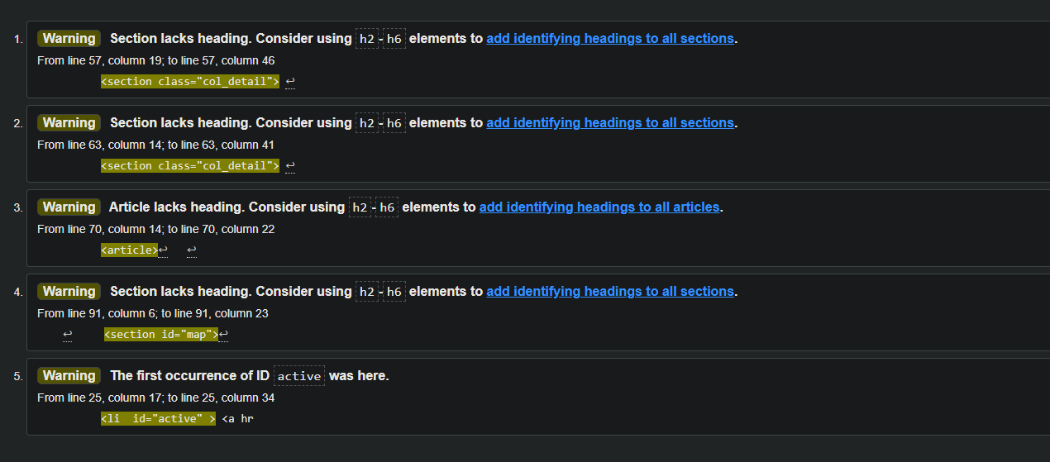

workout.html

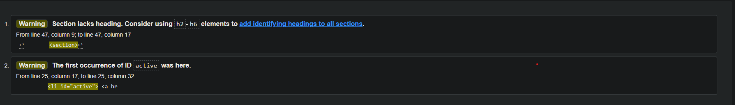

diettips.html



questions.html

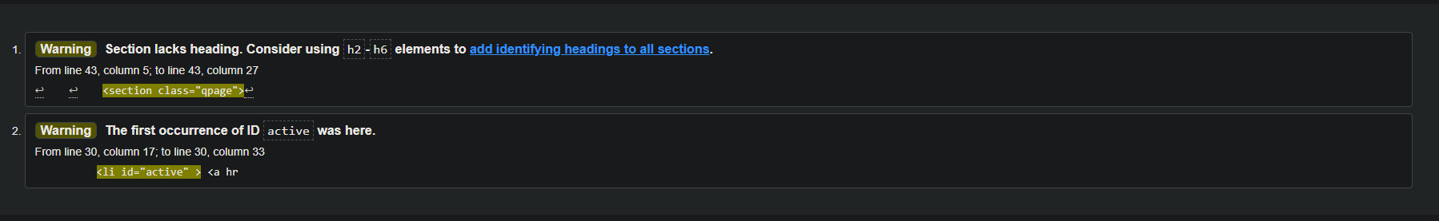

**Design idea**

For my website I tried to stick to my design plans as much as possible. But I did make some changes which I think was an improvement to my plans.

**Github link and website link**

<https://github.com/Tomasgris01/HealthWebsite>

<https://tomasgris01.github.io/HealthWebsite/>

**Home Page**

This page is the introduction to my website. I’ve a section talking about what the website is and what the goals are. In top of the page, I have navigation with background images. I’ve a small article with a image behind it. I have also had a map on the page to so the user knows where we are.

**Workout**

In my workout page I have a workout video with tips in the aside. I have paragraph on different tips on working out.

**Diet**

On this page I have information on diet I also have unordered list

**Q and A**

On this page I just have common asked questions which when clicked the answer will drop down.

Declaration

I the undersigned declare that the project material, which I now submit, is my own work. This material or project has not previously been submitted for any other assignment. Any assistance received by way of borrowing from previous work, or the work of others has been cited and acknowledged within the work. I make this declaration in the knowledge that a breach of the rules pertaining to project submission may carry serious consequences. We are aware that the project will not be accepted unless this form has been handed in along with the project.

Website Topic: Health and fitness

Student name: Tomas Grismanauskas

Student number: S000210995

Date: 18/04/21